**JAVA Assignment 2**

1.

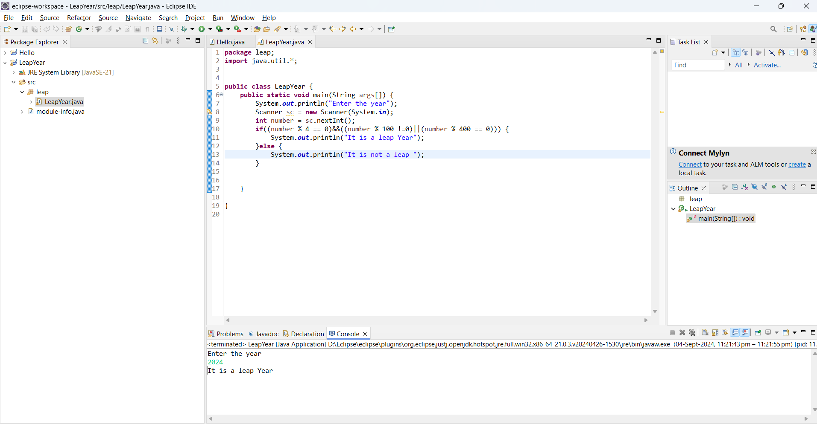

2.

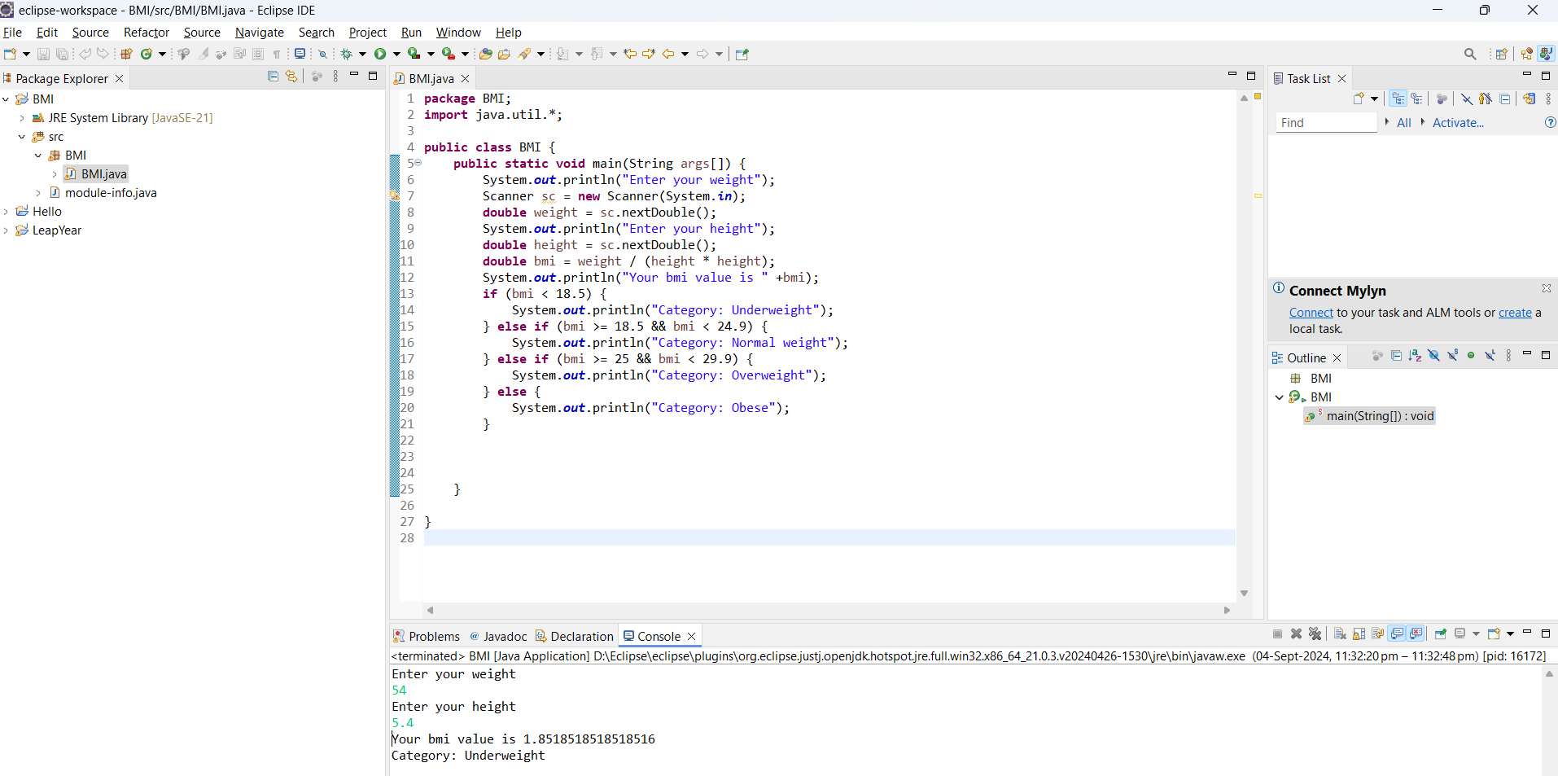

3.

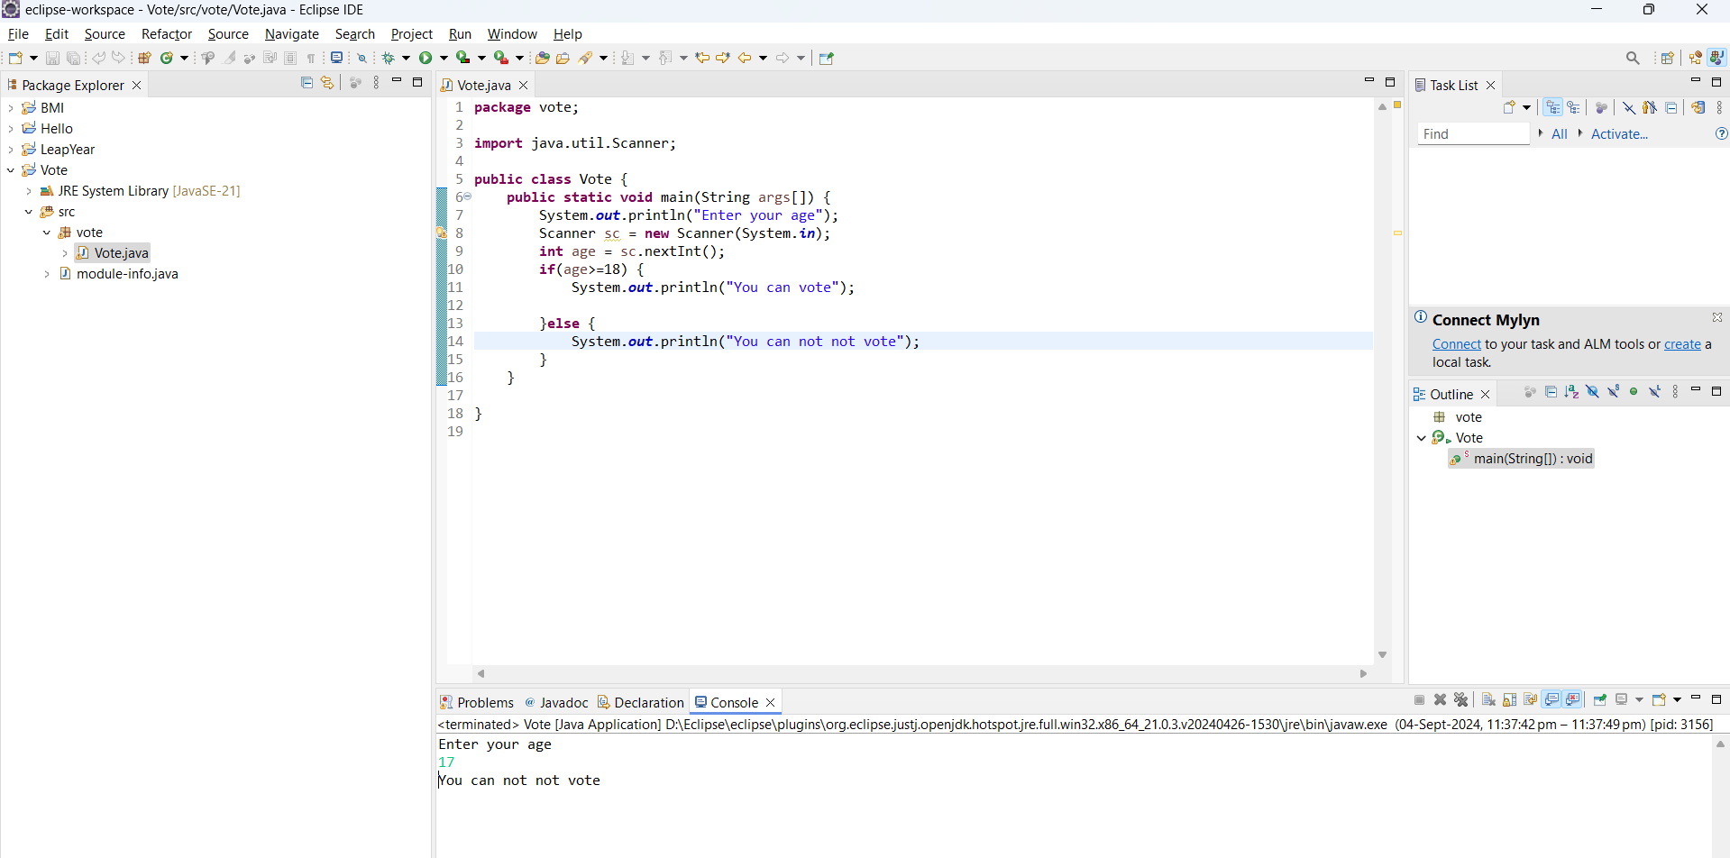

4.

**Source code**

**package** season;

**import** java.util.*;

**public** **class** Season {

**public** **static** **void** main(String[] args) {

Scanner scanner = **new** Scanner(System.***in***);

System.***out***.print("Enter the month number (1-12): ");

**int** month = scanner.nextInt();

String season;

**switch** (month) {

**case** 12:

**case** 1:

**case** 2:

season = "Winter";

**break**;

**case** 3:

**case** 4:

**case** 5:

season = "Spring";

**break**;

**case** 6:

**case** 7:

**case** 8:

season = "Summer";

**break**;

**case** 9:

**case** 10:

**case** 11:

season = "Autumn";

**break**;

**default**:

season = "Invalid month number";

**break**;

}

System.***out***.println("The season is: " + season);

}

}

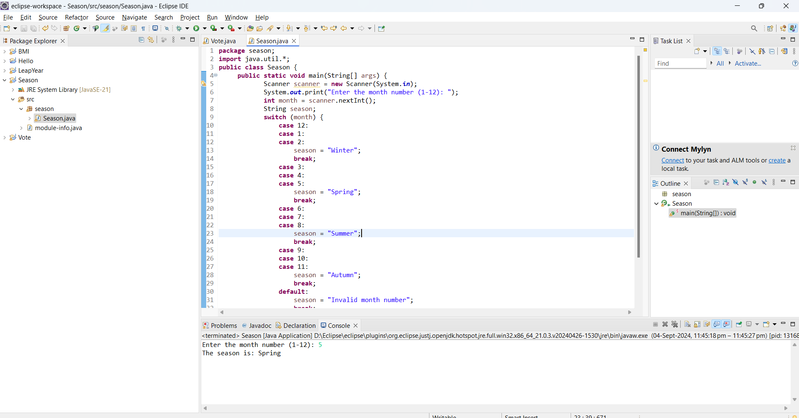

5.

**Source Code**

**package** shapeAreaCalculator;

**import** java.util.Scanner;

**public** **class** ShapeAreaCalculator {

**public** **static** **void** main(String[] args) {

Scanner scanner = **new** Scanner(System.***in***);

System.***out***.println("Select a shape to calculate the area:");

System.***out***.println("1. Circle");

System.***out***.println("2. Square");

System.***out***.println("3. Rectangle");

System.***out***.println("4. Triangle");

**int** choice = scanner.nextInt();

**switch** (choice) {

**case** 1:

System.***out***.print("Enter the radius of the circle: ");

**double** radius = scanner.nextDouble();

**double** circleArea = 3.14159 * radius * radius;

System.***out***.println("The area of the circle is: " + circleArea);

**break**;

**case** 2:

System.***out***.print("Enter the side length of the square: ");

**double** side = scanner.nextDouble();

**double** squareArea = side * side;

System.***out***.println("The area of the square is: " + squareArea);

**break**;

**case** 3:

System.***out***.print("Enter the length of the rectangle: ");

**double** length = scanner.nextDouble();

System.***out***.print("Enter the width of the rectangle: ");

**double** width = scanner.nextDouble();

**double** rectangleArea = length * width;

System.***out***.println("The area of the rectangle is: " + rectangleArea);

**break**;

**case** 4:

System.***out***.print("Enter the base length of the triangle: ");

**double** base = scanner.nextDouble();

System.***out***.print("Enter the height of the triangle: ");

**double** height = scanner.nextDouble();

**double** triangleArea = 0.5 * base * height;

System.***out***.println("The area of the triangle is: " + triangleArea);

**break**;

**default**:

System.***out***.println("Invalid choice. Please select a valid shape.");

**break**;

}

}

}

**Output**

